

Project Semester - VIII

January 10 to April 20, 2019

Department of Computer Science Engineering & Information Technology Symbiosis Institute of Technology, Pune

Final Year Project Report on

AI CHATBOT

Submitted by:

Dhruv Patel 15070121112

Ishan Yadav 15070121124

Prashant Mall 15070121146

Saurabh Shingte 15070121160

Under the Guidance of:

|  |
| --- |
| Dr. Swati Ahirrao |
| Associate Professor (CS&IT), |
| Symbiosis Institute of Technology, Pune |

ACKNOWLEDGEMENT

This Project itself is an acknowledgment of the inspiration, drive and technical assistance contributed by many individuals. This project would have never seen the light of this day without the help and guidance we have received.

We would like to express our profound thanks to Dr. Swati Ahirrao, Associate Professor (CS&IT), Symbiosis Institute of Technology, for her help and guidance throughout our project tenure.

We are grateful to Parul Khare for giving us an opportunity to carry out the project for their organization.

Thank You!

TAble of Contents

1. INTRODUCTION 03

2. PROJECT SYNOPSIS 04

3. SOFTWARE REQUIREMENT AND SPECIFICATION 05

3.1 HARDWARE REQUIREMENTS …………………………………………………… 05

3.2 SOFTWARE REQUIREMENTS AND TOOLS ..……………………………….. 06

4. Software Architecture Used 08

4.1 MVC MODEL FOR AI CHATBOT…………………………………………………… 08

4.2 PIPE AND FILTER ARCHITECTURE……………………………………………….. 11

5. PROJECT FLOW 13

5.1 DIALOGFLOW OVERVIEW ..……………………………………………………….. 13

5.2 NATURAL LANGUAGE PROCESSING FOR SEMANTIC ANALYSIS …… 16

5.3 KNOWLEDGE CONNECTORS ..………………………………………………………18

5.3 KNOWLEDGE CONNECTORS ..………………………………………………………19

5.4 GOOGLE INDEXING AND WEB SEO …………………………………………….. 21

6. project Implementation 22

7. conclusion 24

# INTRODUCTION

Chatbots, or conversational interfaces as they are also known, present a new way for individuals to interact with computer systems. Chatbot allows a user to simply ask questions in the same manner that they would address a human. The most well-known chatbots currently are voice chatbots: Alexa and Siri.

A chatbot can be used anywhere a human is interacting with a computer system. These are the areas where the fastest adoption is occurring:

**Customer Service**: A chatbot can be used as an “assistant” to a live agent, increasing the agent’s efficiency. When trained, they can also provide service when the call center is closed, or eventually even act as an independent agent, if desired.

**Sales/Marketing/Branding:**  Chatbots can be used for sales qualification, ecommerce, promotional campaigns, or as a branding vehicle.

**Human Resources:**  An HR chatbot can help with frequently asked questions (“how many vacation days do I have left?”) and can act as an onboarding assistant.

Economically offer 24/7 service

Improve

Reach

Reduce

Increase revenue.

Economically offer 24/7 Service

# PROJECT SYNOPSIS

Banking AI Chatbot

We are intending to develop an AI based Chatbot which will answer queries of the bank employees. The Database will be in MySQL and the chatbot will be integrated in an app built in Ionic 3 Framework.

*Features of our chatbot:*

* It is an android application.
* It will answer all bank employee queries in voice or text form.
* If the answer is not available, the system will directly email the employee with the answer in two working days.

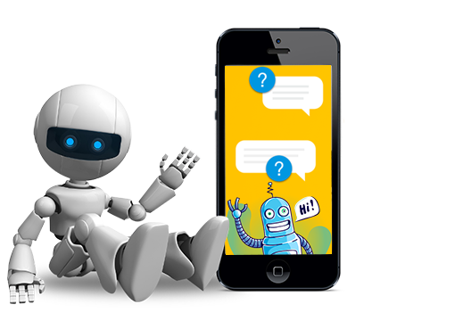

# SOFTWARE REQUIREMENT AND SPECIFICATION

3.1 Hardware Requirements:

Following were the specifications of the hardware used in development of the product:

|  |  |
| --- | --- |
| Hardware | Name |
| Processor | Intel Core i7-4720HQ |
| Frequency | 3.60Ghz |
| Core | 4 |
| RAM | 8 GB |
| Storage | 1 TB |
| GPU | Nvidia GTX 950M |

Following were the specifications of the hardware used for testing of the product:

|  |  |
| --- | --- |
| Hardware | Name |
| Processor | Intel i5 |
| Frequency | 4.20GHz |
| Core | 4 |
| RAM | 8 GB |
| Storage | 1 TB |
| GPU | Radeon Pro 575 |

3.2 Software Requirements / Tools:

1. Atom
   1. ATOM is a powerful IDE which supports several languages.
   2. It has a vast library of add on packages which help in editing and

maintain the code.

* 1. It has hierarchical view method for project files.

1. Dialog Flow



* 1. Dialog Flow is powered by Google's machine learning.
  2. It is built on Google infrastructure.
  3. It uses machine learning to understand what users say.

1. MySQL
   1. 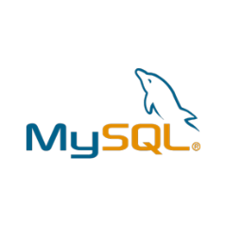MySQL is open source RDBMS that uses Structured Query Language

(SQL).

* 1. It is globally renowned for being the most secure and reliable database management system.
  2. It provides unmatched scalability and is high performance.

1. Postman
   1. 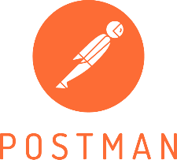Postman is a Google Chrome app for interacting with HTTP APIs.

It presents you with a friendly GUI for constructing requests and

reading responses.

* 1. It is a powerful HTTP Client for testing web services with help of REST API call.

1. Google Chrome
   1. Google Chrome is a freeware web browser developed by Google LLC.

Assumptions:

1. Basic android application is already created.
2. Relevant data is provided for data entry.

Dependencies:

1. MySQL Server
   1. The database server should always be stable and running.
   2. The port number should not be changed and allow remote connections.

# SOFTWARE ARCHITECTURE USED

# 4.1 MVC Model for AI Chatbot

# 

1. Model
   1. AI Chatbot will answer all the queries of the bank employee and if the query solution is not available in the database then it will send the solution to the user in two working days via mail.
   2. In this user will enter the query and query is being processed through NLP and output would be fetched from database and user would get response in the form of voice/text form.
2. View
   1. It contains one view page in which all users will enter query and on the same page user will get response of it. Hence only one view page is required.
   2. It contains a text area for query and search for voice option.
3. Controller
   1. It controls the data flow between model and view. The most important is admin, there would be admin database which will store all the query results.
   2. Query is analyzed by admin database and sent to model, from there if the query is present in database then it will be transferred to controller and since there is only one view, user can see the output on the view page.
   3. 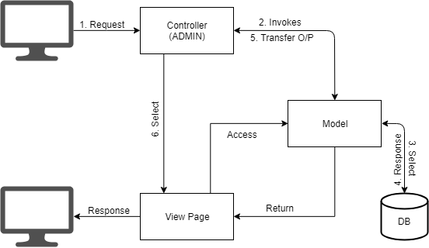

# 

# 4.2 Pipe and Filter Architecture for AI Chatbot

# We have used pipe and filter architecture for our project. A very simple, yet powerful architecture, that is also very robust. It consists of any number of components (filters) that transform or filter data, before passing it on via connectors (pipes) to other components. The filters are all working *at the same time*. The architecture is often used as a simple sequence, but it may also be used for very complex structures.

# 

INPUT: In this case input acts a pump i.e. a data source. The user is responsible for the inputting the text in the chatbot.

QUERY: This is the first filter of the architecture. Whatever the user inputs in the UI is seen as the query for the chatbot.

INTENTS: **Intents are used by our** agent to map user input to responses. In each intent, you define examples of user utterances that can trigger the intent, what to extract from the utterance, and how to respond.

NLP: Natural language processing is used to perform semantic analysis on the intent.

EXTERNAL API’s: During a conversation, fulfillment allows you to use the information extracted by Dialogflow's natural language processing to generate dynamic responses or trigger actions on your back-end.

DATABASE: The responses to a normal textual query are stored in the database.

RESPONSE: The resulting query is the response.

OUTPUT: The response is shown in the textual format on the UI. The output acts as a sink in this architecture.

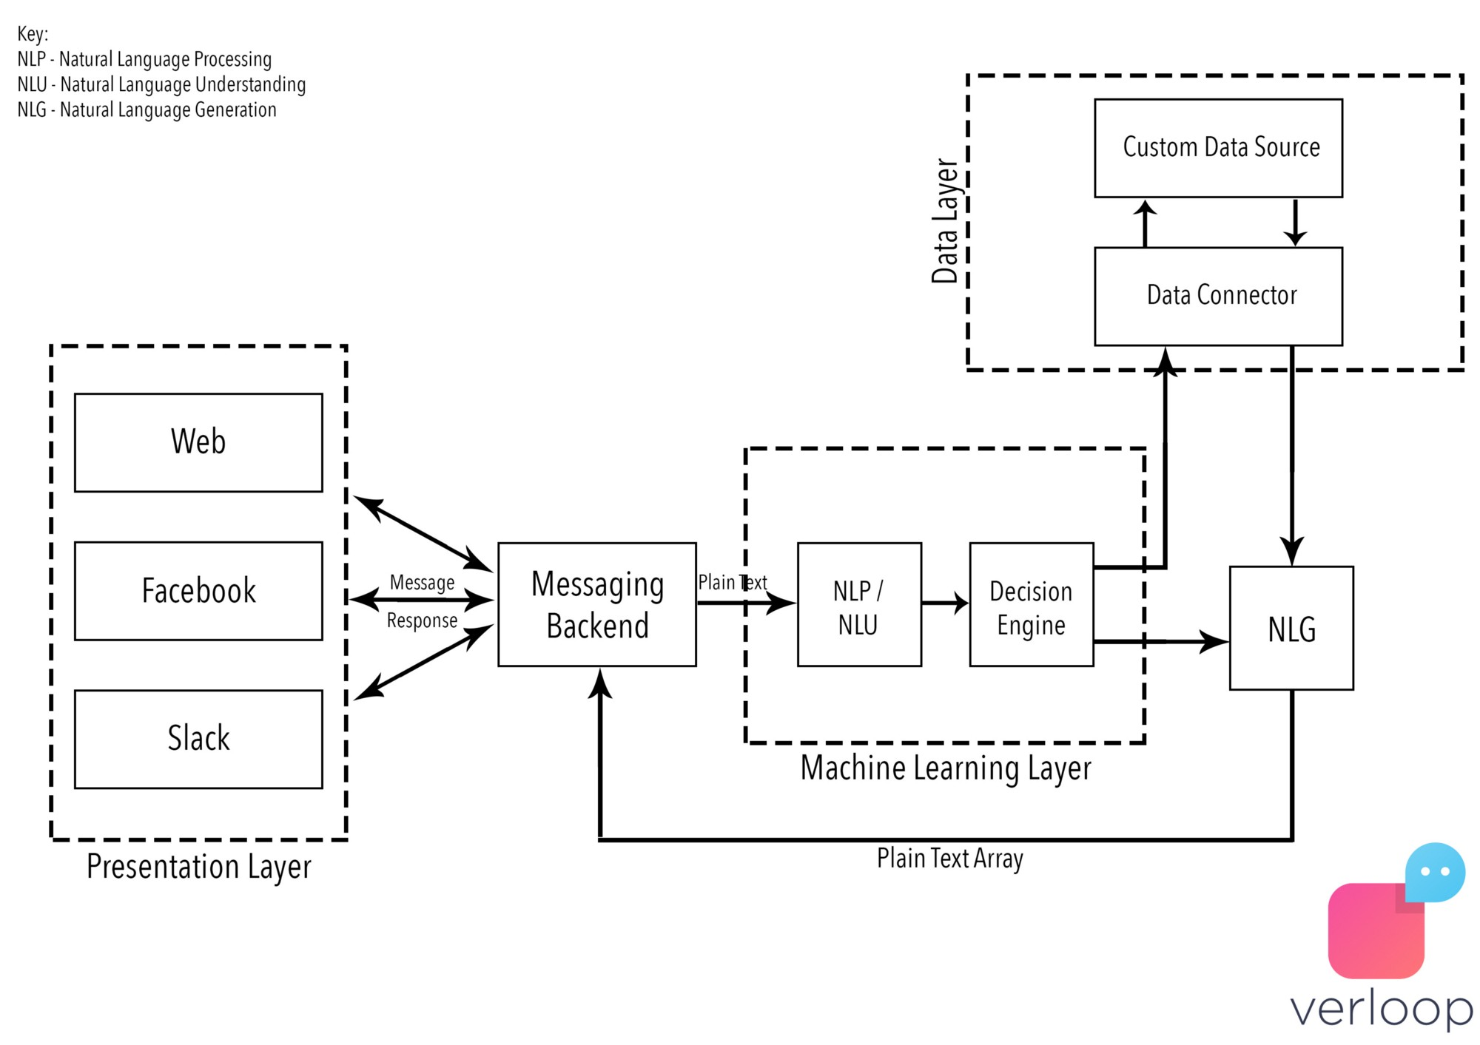

# PROJECT FLOW

# 5.1 Dialogflow Overview

# Dialogflow lets you build conversational interfaces on top of your products and services by providing a powerful natural language understanding (NLU) engine to process and understand natural language input.

# When we use Dialogflow, we create *agents* that can understand the vast and varied nuances of human language and translate that to standard and structured meaning that your apps and services can understand.

# 

# 

An agent helps us process user input into structured data that we can use it to return an appropriate response. We define all of these things inside one or many *intents*, which define how to map user input to a corresponding response.

A basic intent is comprised of these components:

* [Training phrases](https://dialogflow.com/docs/intents/training-phrases): Defines example phrases of what users can say. Dialogflow uses these training phrases and naturally expands them to many more similar phrases to build a language model that accurately matches user input. Through further training and machine learning, Dialogflow builds a more robust and varied language model to better match user input.
* [Action and Parameters](https://dialogflow.com/docs/intents/actions-parameters): To improve an intent's language model, you can also annotate your training phrases with *entities*, or categories of data that you want Dialogflow to match. This lets you tell Dialogflow that you want a particular type of input and to not just match the literal input of the user. Dialogflow extracts matched entities as parameters from the training phrases. You can then process these parameters in logic called *fulfillment* to further customize a response to the user. You'll learn about fulfillment later in this document.
* [Responses](https://dialogflow.com/docs/intents/responses): Defines a text, speech, or visual response to the user, which usually prompts users in a way that lets them know what to say next or that the conversation is ending. To send responses, you can use Dialogflow's built-in response handler or call fulfillment to process the extracted data and return a response back to Dialogflow.

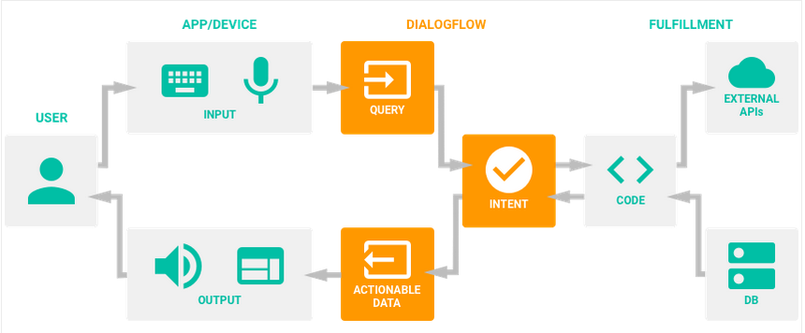

1. When users say something, referred to as an *utterance*, your agent matches the utterance to an appropriate intent, otherwise known as *intent classification*. An intent is matched if the language model for that intent can closely or exactly match the user utterance. You define the language model by specifying *training phrases*, or examples of things users might want to say. Dialogflow takes these training phrases and expands upon them to create the intent's language model.
2. Once your agent matches an intent, it extracts *parameters* that you need from the utterance. This can be a color, name, date, or a host of other data categories called *entities*. Dialogflow defines a large set entities that categorize extracted parameters, or you can create your own. You define what to extract in your training phrases as well, annotating specific parts of the training phrases to specify what parameters you want to extract.
3. You then send a response that can either prompt users for more information to continue the conversation or to just end the conversation. If more information is required, this back and forth happens again. Your agent matches a user utterance with an intent, extracts parameters, and returns a response. Dialogflow includes an easy-to-use response handler to return simple, usually static responses. If you want to return more catered responses, you can use logic called *fulfillment* to process any extracted parameters and return a response that is more dynamic or useful.

# 5.2 Natural language processing Semantic Analysis

# The purpose of semantic analysis is to draw exact meaning, or you can say dictionary meaning from the text. The work of semantic analyzer is to check the text for meaningfulness.

Semantic analysis can be divided into the following two parts −

### Studying meaning of individual word

It is the first part of the semantic analysis in which the study of the meaning of individual words is performed. This part is called lexical semantics.

### Studying the combination of individual words

In the second part, the individual words will be combined to provide meaning in sentences. The most important task of semantic analysis is to get the proper meaning of the sentence. For example, analyze the sentence **“Ram is great.”** In this sentence, the speaker is talking either about Lord Ram or about a person whose name is Ram. That is why the job, to get the proper meaning of the sentence, of semantic analyzer is important.

Followings are some important elements of semantic analysis −

### Hyponymy

It may be defined as the relationship between a generic term and instances of that generic term. Here the generic term is called hypernym and its instances are called hyponyms. For example, the word color is hypernym and the color blue, yellow etc. are hyponyms.

### Homonymy

It may be defined as the words having same spelling or same form but having different and unrelated meaning. For example, the word “Bat” is a homonymy word because bat can be an implement to hit a ball or bat is a nocturnal flying mammal also.

### Polysemy

Polysemy is a Greek word, which means “many signs”. It is a word or phrase with different but related sense. In other words, we can say that polysemy has the same spelling but different and related meaning. For example, the word “bank” is a polysemy word having the following meanings −

* + A financial institution.
  + The building in which such an institution is located.
  + A synonym for “to rely on”.

### Building Blocks of Semantic System

In word representation or representation of the meaning of the words, the following building blocks play an important role −

* **Entities** − It represents the individual such as a particular person, location etc. For example, Haryana. India, Ram all are entities.
* **Concepts** − It represents the general category of the individuals such as a person, city, etc.
* **Relations** − It represents the relationship between entities and concept. For example, Ram is a person.
* **Predicates** − It represents the verb structures. For example, semantic roles and case grammar are the examples of predicates.

Now, we can understand that meaning representation shows how to put together the building blocks of semantic systems. In other words, it shows how to put together entities, concepts, relation and predicates to describe a situation. It also enables the reasoning about the semantic world.

Semantic analysis uses the following approaches for the representation of meaning −

* First order predicate logic (FOPL)
* Semantic Nets
* Frames
* Conceptual dependency (CD)
* Rule-based architecture
* Case Grammar
* Conceptual Graphs

# 5.3 Knowledge Connectors

# Knowledge connectors complement defined intents. They parse documents (for example, FAQs or articles) to find automated responses. To configure them, you define one or more knowledge bases, which are collections of documents. You can enable knowledge bases for your agent, so all detect intent requests may find automated responses using your knowledge bases. Alternatively, you can specify one or more knowledge bases in your individual detect intent requests.

# 

# 5.4 Database Used

# We have used MySQL for storing our data. It is a type of Relational Database Management System (RDBMS) that:

* Enables you to implement a database with tables, columns and indexes.
* Guarantees the Referential Integrity between rows of various tables.
* Updates the indexes automatically.
* Interprets an SQL query and combines information from various tables.

# 

# 

# 

# 5.5 Google Indexing and Web SEO

# Indexing is the process of adding web pages into Google search.

# When crawling is done then after the results get put into Google index.

# A good idea for increase high rank in search engines is to let only vital parts of your blog/website be indexed.

# The main reason why we need indexing is because Knowledge base performs crawling on a html page.

# 

# PROJECT IMPLEMENTATION

# 

# The above image is of the knowledge base. It contains all the questions and their answers which the user might ask.

# 

# Above is the image of the working chatbot. The query which the user ask goes through sentimental analysis, from which the reply of the simplified query is mapped from the database and shown to the user. The input and output can be in textual as well as in voice format.

# CONCLUSION

Our overall experience from the project has been amazing, the journey was full of ups and downs, success and failures which finally resulted in us learning a lot. With mentors like Dr. Swati Ahirrao we never felt like we lacked supervision or any expert guidance during our project tenure. Having the opportunity to work for an industrial project gave us great exposure to real world problems and made us capable to find their solutions. We have been able to meet and network new people that we are sure will be able to help us with opportunities in the future. This industrial project has made us realize the value of working together as a team.